**ANTICLOCKWISE ROTATION OF STEPPER MOTOR USING 8051 USING PROTEUS**

**AIM:**

To write an assembly language program to rotate the Stepper Motor in anti-clockwise direction in 8051 using Proteus

**SOFTWARE REQUIRED:**

* Proteus 8 software.

**PROGRAM:**

ORG 00H ; Start program at address 0x00

MAIN: MOV P2, #0F0H ; Initialize Port 2 as output (upper nibble)

ACALL COUNTERCLOCKWISE ; Rotate stepper motor in counterclockwise direction

ACALL DELAY ; Call delay

SJMP MAIN ; Repeat forever

; Subroutine to rotate stepper motor counterclockwise

COUNTERCLOCKWISE:

MOV A, #08H ; Load step 4 (1000)

MOV P2, A

ACALL DELAY

MOV A, #04H ; Load step 3 (0100)

MOV P2, A

ACALL DELAY

MOV A, #02H ; Load step 2 (0010)

MOV P2, A

ACALL DELAY

MOV A, #01H ; Load step 1 (0001)

MOV P2, A

ACALL DELAY

RET ; Return from subroutine

; Subroutine to generate a delay

DELAY:

MOV R1, #0FFH ; Load delay counter (outer loop)

DELAY_LOOP1:

MOV R2, #0FFH ; Load delay counter (inner loop)

DELAY_LOOP2:

DJNZ R2, DELAY_LOOP2 ; Decrement inner loop counter

DJNZ R1, DELAY_LOOP1 ; Decrement outer loop counter

RET ; Return from subroutine

END

**CIRCUIT DIAGRAM:**

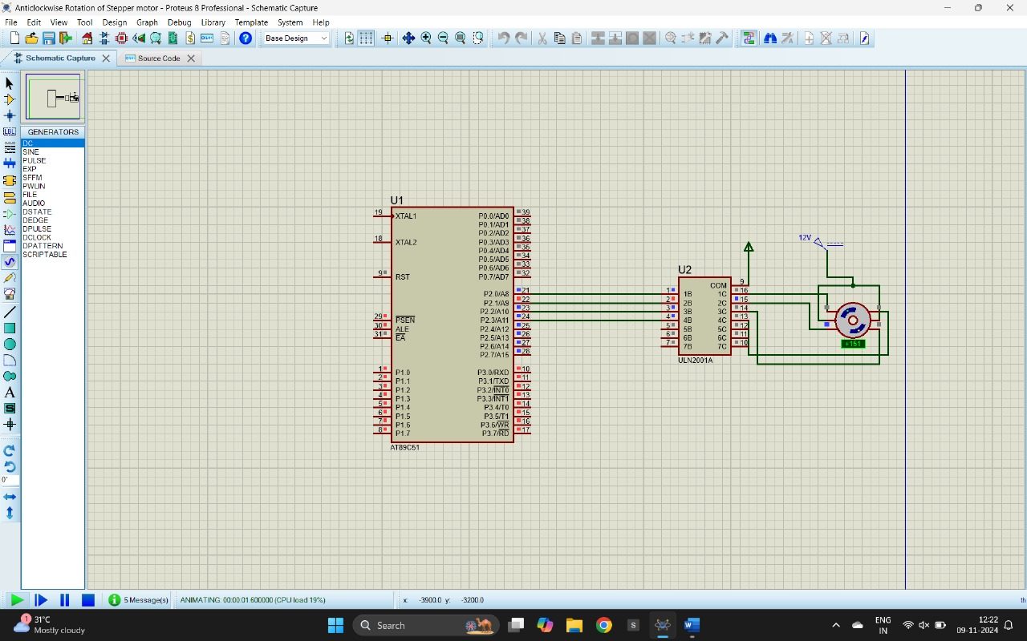

**OUTPUT:**

The stepper motor is rotating in clockwise direction in steps.

**RESULT:**

Thus, the program has been successfully verified and executed.